2014 Amendment to the Tompkins County

Coordinated Public Transit-Human Service Transportation Plan

Report: The ITCTC adopted the Coordinated Public Transit–Human Service Transportation Plan (Coordinated Plan) in October 2007 and has amended the plan annually from 2009-2013 to identify a list of priority projects for funding. The purpose of this amendment is to revise the Plan’s priorities for 2015-16.

The Federal Transportation Law Moving Ahead for Progress in the 21st Century Act (MAP-21) requires all projects proposed for the FTA Section 5310 Enhanced Mobility for Seniors and Individuals with Disabilities Program be included in a Coordinated Transportation Plan. Further, federal guidance advises using the coordinated planning process as a best practice for developing mobility management and Job Access operating assistance projects in the Section 5307 Urban Formula and 5311 Rural Formula transit programs.

The proposed priority projects will be considered for $576,794 in federal funding through existing grants or new grant opportunities in 2015. The funding sources are as follows:

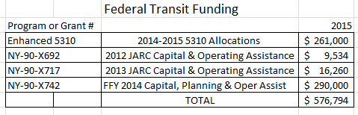

Table A, included below, lists the specific priority projects to be included in the Coordinated Plan as FTA Coordinated Transportation Projects for 2015-2016. They are listed in three project categories as follows:

- GADABOUT’s Section 5310 Enhanced Mobility for Seniors and Individuals with Disabilities projects for 2015. These projects were approved in 2013 for 2014. NYSDOT rescheduled the 5310 application process to 2015.

- Special Community Mobility (SCM) Projects for 2015. I-TCTC conducted a solicitation for projects from September – October 2014. The Coordinated Transportation Plan Committee reviewed and recommended the projects on 11/19/2014. The TCAT/Tompkins County Working Group reviewed and recommended the projects on Dec. 1, 2014.

- Way2Go community mobility education project. Tompkins County is procuring a contractor for the project to be completed in March 2015.

Actions Requested: Planning Committee recommendation and Policy Committee approval of the proposed 2015 Amendment to the Tompkins County Coordinated Public Transit–Human Service Transportation Plan to revise the Plan’s priority projects as shown in Table A.

Table A. Priority Projects for FTA Coordinated Transportation Projects for 2015

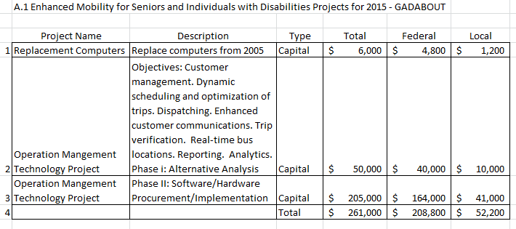

Table A. Priority Projects for FTA Coordinated Transportation Projects for 2015 Cont’d

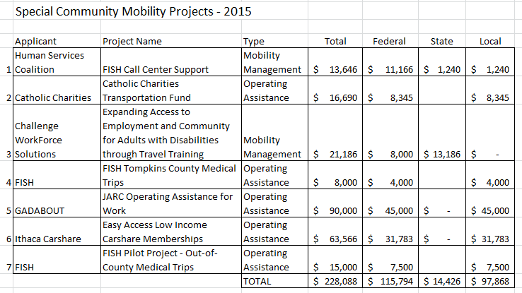

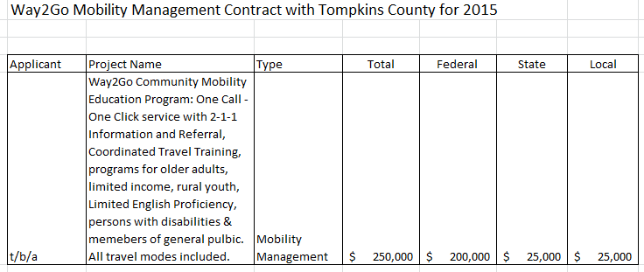

Approved Dec 16, 2014 by the Policy Committee of the Ithaca-Tompkins County Transportation Council.

